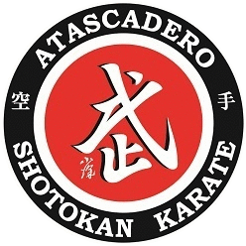

ACH Recurring Payment Authorization Form
Schedule your payment to be automatically deducted from your checking or savings account.
Just complete and sign this form to get started!

Recurring Payments Will Make Your Life Easier:
- It’s convenient (saving you time and postage)
- Your payment is always on time (even if you’re out of town), eliminating late charges

Here’s How Recurring Payments Work:
You authorize regularly scheduled charges to your checking or savings account. You will be charged the amount indicated below each billing period. A receipt for each payment will be emailed to you and the charge will appear on your bank statement as an “ACH Debit.” You agree that no prior-notification will be provided unless the date or amount changes, in which case you will receive notice from us at least 10 days prior to the payment being collected.

Please complete the information below:

I ____________________________ authorize Atascadero Shotokan Karate to charge my bank account
(Full Name)
indicated below on the 1st of each month for payment of my tuition for ____________________________
(Student(s)
Billing Address ____________________________ Phone#________________________
City, State, Zip ____________________________ Email ________________________
Account Type: Checking Savings
Name on Acct _______________________________
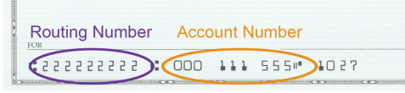
Bank Name _______________________________
Account Number_______________________________
Bank Routing #_______________________________ <------- 9 Digits, please attach a voided check
Bank City/State _______________________________
Signature Date

I understand that this authorization will remain in effect until I cancel it in writing, and I agree to notify Atascadero Shotokan Karate in writing of any changes in my account information or termination of this authorization at least 15 days prior to the next billing date. If the above noted periodic payment dates fall on a weekend or holiday, I understand that the payment may be executed on the next business day. I understand that because this is an electronic transaction, these funds may be withdrawn from my account as soon as the above noted periodic transaction dates. In the case of an ACH Transaction being rejected for Non Sufficient Funds (NSF) I understand that Atascadero Shotokan Karate may at its discretion attempt to process the charge again within 30 days, and agree to an additional $25 charge for each attempt returned NSF which will be initiated as a separate transaction from the authorized recurring payment. I acknowledge that the origination of ACH transactions to my account must comply with the provisions of U.S. law. I agree not to dispute this recurring billing with my bank so long as the transactions correspond to the terms indicated in this authorization form.

